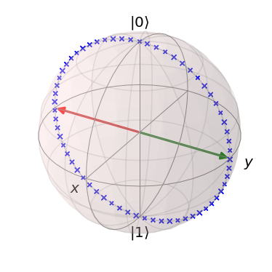

Circuit Design in Quantum Information Science using Qiskit

  - In quantum computing there has been an emergence of tool kits for quantum circuit design. Amongst many of them, one of the most ambitious projects comes from IBM from within their IBM-Q team: qiskit. Being open source and backed by an enormous amount of developers, it is quickly becoming a standard tool kit.
In this talk I will showcase an application of qiskit towards quantum machine learning having a quantum classifier – the so-called Hadamard-classifier – implemented in the mechanics of sci-kit learn standard toolkit for machine learning.
Also, we will delve into an improvement of the Hadamard classifier, the Swap-Test classifier and its implementation on IBM’s newest quantum device, IBMQ-Ourense.

Note on the attendance:
If you ever wondered how “classical” code can be used to program a quantum processor and have brief introduction, this talk might be for you. We will expect Python experience and some background on finite quantum Hilbert spaces (aka Linear Algebra in power-two-dimensional complex vector spaces). If time permits, you may come equipped with laptop equipped with a Jupyter-Lab and the latest qiskit installed. We will open-source code of our (Daniel K. Park and myself) most recent findings!

Happy to be @ KAIST and to see you there!

Carsten Blank (researcher & consultant at data cybernetics)

