Transport in Low-Dimensional Systems from Theory and Experiment: Two-Probe Scanning Spectroscopy on Ge(001)-c(4x2) and Graphene Nanoribbons
Daniel Sánchez-Portal
Centro de Física de Materiales CSIC-UPV/EHU and DIPC, Paseo Manuel de Lardizabal 5, 20018 San Sebastián, Spain
daniel.sanchez@ehu.eus

With the miniaturization of electronic circuits into the single-atom level, methods based on scanning probe microscopy are becoming instrumental to characterize electron transport properties of relevant devices. Here I will present two joint theoretical and experimental studies of electronic transport in low-dimensional systems.
Firstly, I will focus on the electronic transport along the anisotropic Ge(001)-c(4x2) surface with the use of two-probe scanning tunneling spectroscopy (2P-STS) and first-principles transport calculations [1]. We have introduced a method for the determination of the transconductance in our two-probe experimental setup and demonstrated how it captures energy-resolved information about electronic transport through the unoccupied surface states. The sequential opening of two transport channels within the quasi-one-dimensional Ge dimer rows in the surface gives rise to two distinct resonances in the transconductance spectroscopic signal, consistent with phase-coherence lengths of up to 50 nm and anisotropic electron propagation. Theoretical results from ballistic transport simulations allow correlating the observed resonances with different features in the surface band structure (see Figure 1 below).
Secondly, I will present results for the electronic and transport properties of simple devices based on graphene nanoribbons (GNRs) [2] and 7-armchair-GNRs doped with boron [3,4], comparing our findings in the latter case with detailed STS experiments.

References
- M. Kolmer, et al. , Nature Comm., 10 (2019) 1573
- P. Brandimarte, et al., J. Chem. Phys. 146 (2017) 092318
- E. Carbonell-Sanromá, et al., Nano Letters 17 (2017) 50
- E. Carbonell-Sanromá, et al., J. Phys. Chem. C 122(2018) 16092
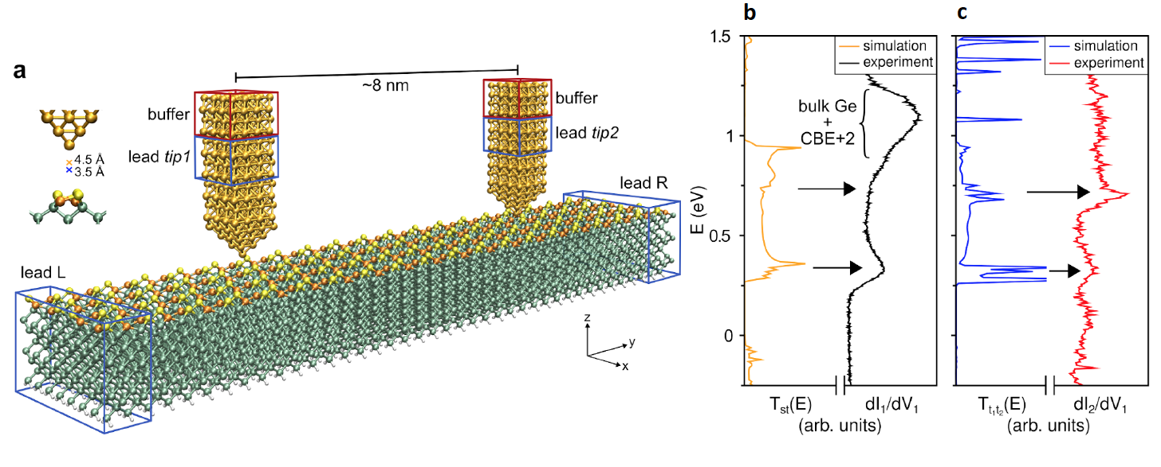
Figure 1. (a) Scheme of our 4-terminal computational setup. Computations were performed with the SIESTA/TranSIESTA package. (b) Comparison between the experimental dI₁/dV₁ spectrum and the calculated surface-to-tip transmission at zero bias for D=4.5 Å (single-tip setup). (c) Comparison between the experimental dI₂/dV₁ spectrum and the tip-to-tip transmission function calculated for D₁=D₂=3.5 Å with the setup represented in panel a. In all calculations the Ge slab valence band edge has been used as a common energy reference.

